Afghanistan
Capital: Kabul
Language: Pashto & Dari
Continent: Asia
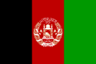

Algeria
Capital: Algiers
Language: Arabic
Continent: Africa
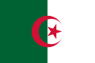
Angola
Capital: Luanda
Language: Portuguese
Continent: Africa
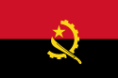
Argentina
Capital: Buenos Aires
Language: Spanish
Continent: South America
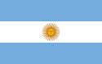
Armenia
Capital: Yerevan
Language: Armenian
Continent: Asia
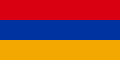
Australia
Capital: Canberra
Language: English
Continent: Australia
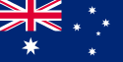
Austria
Capital: Vienna
Language: German
Continent: Europe
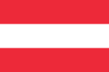
Bangladesh
Capital: Dhaka
Language: Bangla (Bengali)
Continent: Asia
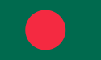
Belgium
Capital: Brussels
Language: Dutch – French – German
Continent: Europe
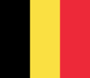
Belize
Capital: Belmopan
Language: English
Continent: North America
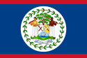
Bolivia
Capital: La Paz – seat of government & Sucre – constitutional
Language: Spanish – Quechua – Aymara – Guarani
Continent: South America
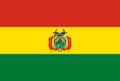
Bosnia
Capital: Sarajevo
Language: Bosnian – Croatian – Servian
Continent: Europe
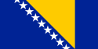
Brazil
Capital: Brasilia
Language: Portuguese
Continent: South America
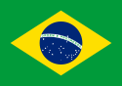
Bulgaria
Capital: Sofia
Language: Bulgarian
Continent: Europe
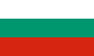
Cambodia
Capital: Phnom Penh
Language: Khmer
Continent: Asia
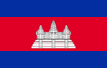
Canada
Capital: Ottawa
Language: English – French
Continent: North America
Chad
Capital: N’Djamena
Language: French – Arabic
Continent: Africa
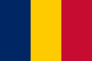
Chile
Capital: Santiago
Language: Spanish
Continent: South America
China
Capital: Beijing
Language: Chinese
Continent: Asia
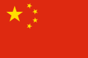
Colombia
Capital: Bogota, D.C.
Language: Spanish
Continent: South America
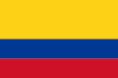
Croatia
Capital: Zagreb
Language: Croatian
Continent: Europe
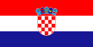
Cuba
Capital: Havana
Language: Spanish
Continent: North America
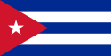
Czech Republic
Capital: Prague
Language: Czech
Continent: Europe
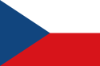
Denmark
Capital: Copenhagen
Language: Danish
Continent: Europe
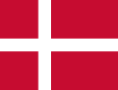
Dominican Republic
Capital: Santo Domingo
Language: Spanish
Continent: North America
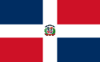
Ecuador
Capital: Quito
Language: Spanish
Continent: South America
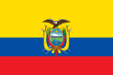
Egypt
Capital - Cairo
Language - Egyptian Arabic
Continent - Africa
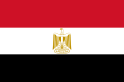
El Salvador
Capital: San Salvador
Language: Castilian
Continent: North America
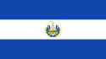
England
Capital: London
Language: English
Continent: Europe
Ethiopia
Capital: Addis Ababa
Language: Amharic
Continent: Africa
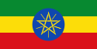
Fiji
Capital: Suva
Language: English
Continent: Australia
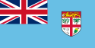
Finland
Capital: Helsinki
Language: Finish – Swedish
Continent: Europe
France
Capital: Paris
Language: French
Continent: Europe
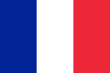
Germany
Capital: Berlin
Language: German
Continent: Europe
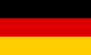
Ghana
Capital: Accra
Language: English
Continent: Africa
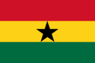
Greece
Capital: Athens
Language: Greek
Continent: Europe
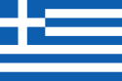
Guatemala
Capital: Guatemala City
Language: Spanish
Continent: North America
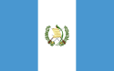
Iceland
Capital: Reykjavik
Language: Icelandic
Continent: Europe
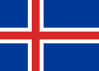
India
Capital: New Delhi
Language: Hindi – English
Continent: Asia
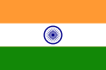
Indonesia
Capital: Jakarta
Language: Indonesian
Continent: Asia
Iran
Capital: Tehran
Language: Persian
Continent: Asia
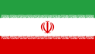
Iraq
Capital: Baghdad
Language: Arabic – Kurdish
Continent: Asia
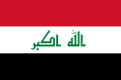
Ireland
Capital: Dublin
Language: Irish Gaelic – English
Continent: Europe
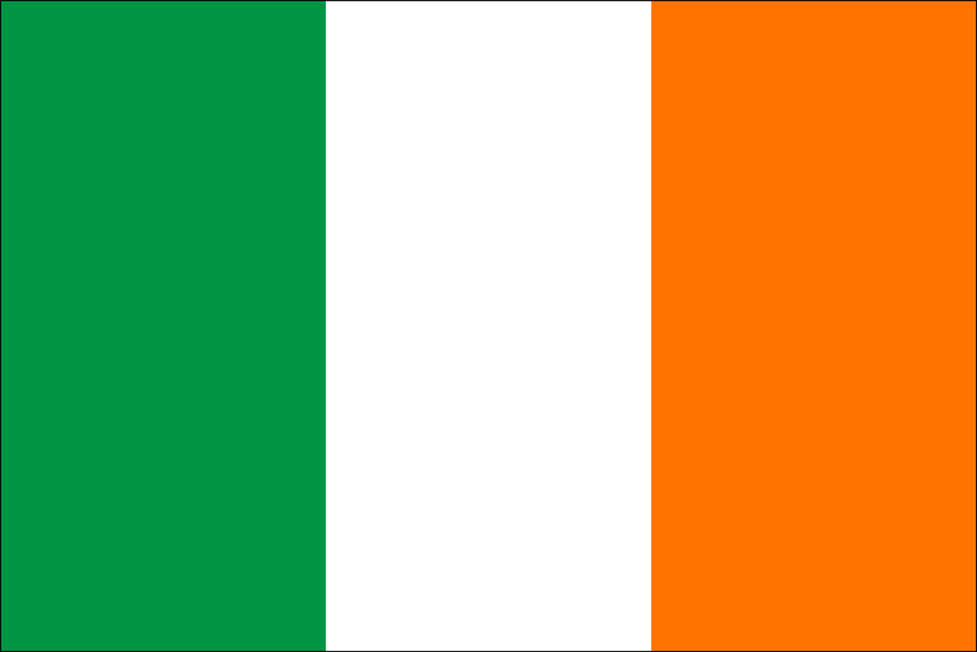
Israel
Capital: Jerusalem
Language: Hebrew – Arabic
Continent: Asia
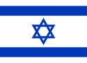
Italy
Capital: Rome
Language: Italian
Continent: Europe
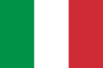
Japan
Capital: Tokyo
Language: Japanese
Continent: Asia
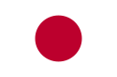
Kenya
Capital: Nairobi
Language - Swahili – English
Continent - Africa
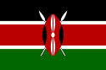
Kuwait
Capital: Kuwait City
Language: Arabic
Continent: Asia
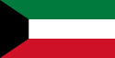
Laos
Capital: Vientiane
Language: Lao
Continent: Asia
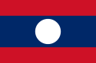
Lebanon
Capital: Beirut
Language: Arabic
Continent: Asia
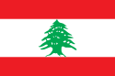
Liberia
Capital: Monrovia
Language: English
Continent: Africa
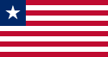
Libya
Capital: Tripoli
Language: Arabic
Continent: Africa
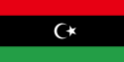
Liechtenstein
Capital: Vaduz
Language: German
Continent: Europe
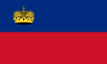
Lithuania
Capital: Vilnius
Language: Lithuanian
Continent: Europe
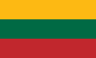
Luxembourg
Capital: Luxembourg City
Language: French – German – Luxembourger
Continent: Europe
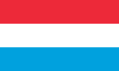
Malaysia
Capital: Kuala Lumpur
Language: Malaysian
Continent: Asia
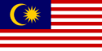
Mexico
Capital: Mexico City
Language: Spanish
Continent: North America
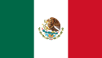
Mongolia
Capital: Ulan Bator
Language: Mongolian
Continent: Asia
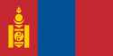
Myanmar
Capital: Naypyidaw
Language: Burmese
Continent: Asia
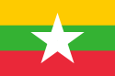
Nepal
Capital: Kathmandu
Language: Nepali
Continent: Asia
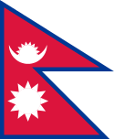
The Netherlands
Capital: Amsterdam
Language: Dutch
Continent: Europe
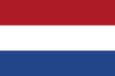
New Zealand
Capital: Wellington
Language: English
Continent: Australia
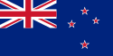
Nicaragua
Capital: Managua
Language: Spanish
Continent: North America
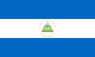
Niger
Capital: Niamey
Language: French
Continent: Africa
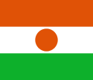
Nigeria
Capital: Abuja
Language: English
Continent: Africa
North Korea
Capital: Pyongyang
Language: Korean
Continent: Asia
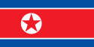
Norway
Capital: Oslo
Language: Norwegian
Continent: Europe
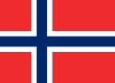
Pakistan
Capital: Islamabad
Language: English – Urdu
Continent: Asia
Panama
Capital: Panama City
Language: Spanish
Continent: North America
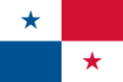
Paraguay
Capital: Asuncion
Language: Spanish
Continent: South America
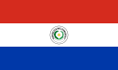
Peru
Capital: Lima
Language: Spanish
Continent: South America
The Philippines
Capital: Manila
Language: Filipino – English
Continent: Asia
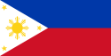
Poland
Capital: Warsaw
Language: Polish
Continent: Europe
Portugal
Capital: Lisbon
Language: Portuguese
Continent: Europe
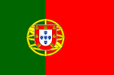
Romania
Capital: Bucharest
Language: Romanian
Continent: Europe
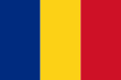
Russia
Capital: Moscow
Language: Russian
Continent: Asia
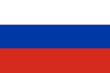
Samoa
Capital: Apia
Language: Samoan
Continent: Australia
Saudi Arabia
Capital: Riyadh
Language: Arabic
Continent: Asia
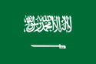
Serbia
Capital: Belgrade
Language: Serbian
Continent: Europe
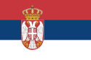
Montenegro
Capital: Podgorica
Language: Montenegrin
Continent: Europe
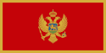
Singapore
Capital: Singapore
Language: English – Malay – Mandarin – Tamil
Continent: Asia
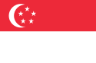
Slovakia
Capital: Bratislava
Language: Slovak
Continent: Europe
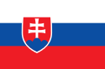
South Korea
Capital: Seoul
Language: Korean
Continent: Asia
Spain
Capital: Madrid
Language: Spanish
Continent: Europe
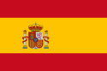
Sri Lanka
Capital: Sri Jayawardenepura Kotte
Language: Sinhala – Tamil – English
Continent: Asia
Sweden
Capital: Stockholm
Language: Swedish
Continent: Europe
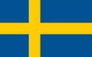
Switzerland
Capital: Bern
Language: German – French – Italian – Romansh
Continent: Europe
Syria
Capital: Damascus
Language: Arabic
Continent: Asia
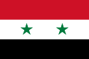
Taiwan
Capital: Taipei
Language: Chinese
Continent: Asia
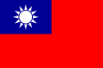
Tanzania
Capital: Dodoma
Language: Swahili – English
Continent: Africa
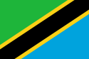
Thailand
Capital: Bangkok
Language: Thai
Continent: Asia
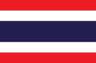
Tonga
Capital: Nuku’alofa
Language: Tongan – English
Continent: Australia
Turkey
Capital: Ankara
Language: Turkish
Continent: Asia
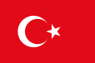
Uganda
Capital: Kampala
Language: Luganda – Southern Luo – Runyankore
Continent: Africa
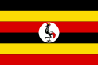
Ukraine
Capital: Kiev
Language: Ukrainian
Continent: Europe
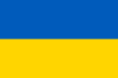
United Arab Emirates
Capital: Abu Dhabi
Language: Arabic
Continent: Asia
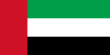
United States
Capital: Washington D.C.
Language: English
Continent: North America
Uruguay
Capital: Montevideo
Language: Spanish
Continent: South America
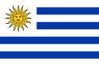
Venezuela
Capital: Caracas
Language: Spanish
Continent: South America
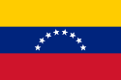
Vietnam
Capital: Hanoi
Language: Vietnamese
Continent: Asia
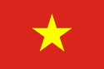
Yemen
Capital: Sana’a
Language: Arabic
Continent: Asia
Zambia
Capital: Lusaka
Language: English
Continent: Africa
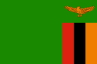
Zimbabwe
Capital: Harare
Language: English – Shona – Ndebele
Continent: Africa
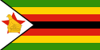
Scotland
Capital: Edinburgh
Language: English
Continent: Europe
Wales
Capital: Cardiff
Language: Welch – English
Continent: Europe
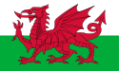
United Kingdom or Great Britain (England, Scotland, Wales; and Northern Ireland)
Capital: London
Language: English
Continent: Europe
